Laboratory 2: Analog Modulation Techniques

ECSE308 - Introduction to Communication Systems and Networks

Group C9

Ismail Faruk (260663521)

Marine Huynh (260743073)

*Abstract - The understanding modulated AM and FM signals is important as they are surrounding us in our daily life. Radio stations are using this standard by modulating a signal to send it over a bandpass frequency range. As signals have multiple frequencies, they can be passed at the same time.*

1. INTRODUCTION

For our second lab, we had to make observations on analog signals. We wanted to understand in more depth the use of modulation and demodulation to retrieve the digital information. This was done on amplitude and frequency modulations as it is commonly known as AM and FM. These techniques are often use in our day to day life, as channels radio are on that standard. For this three part lab, we had to construct different systems using Simulink in MatLab to generate and simulate signals to obverse their input and output.

II. ANALYSIS

First part of the lab consisted of looking over the concept of amplitude modulation (AM). We built a double-sideband (DSB) large carrier (LC) amplitude modulation system followed by a double-sideband (DSB) suppressed-carrier (SC) AM system. We started with the first system.

The output of the spectrum source can be seen below in *Figure 1*. From the bandwidth, we can approximate the frequency to be 2000 Hz, which is the fundamental frequency. The second harmonic is then 4kHz and the third 6kHz.

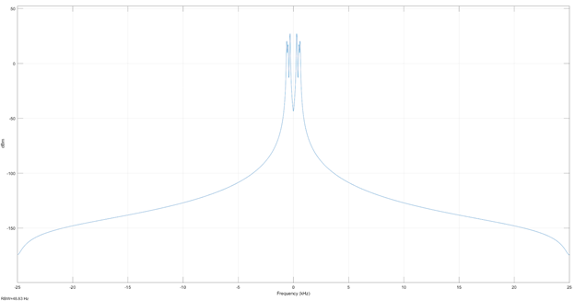

*Figure 1: Spectrum of the source for DSB LC.*

The relationship between the amplitude of the AM signal and the source signal can be observed from the source signal scope and the modulator scope seen in *Figure 2 and 3* respectively.

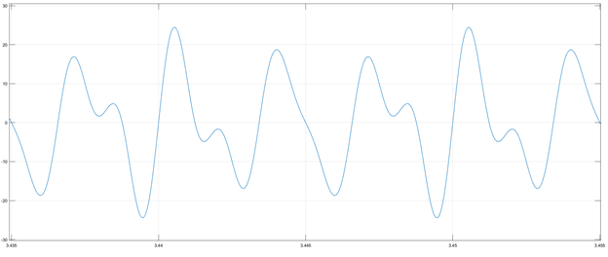

*Figure 2: Scope of the source for DSB LC*.

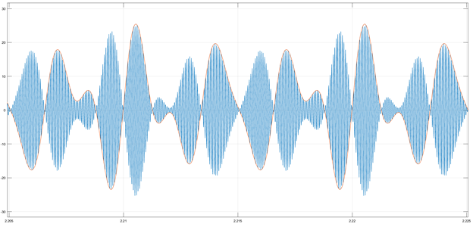

*Figure 3: Scope after modulation for DSB LC.*

We can observe that the amplitude is exactly the same at a specific point. The magnitude of the wave do not differ from the source to the modulated signal. If the two scopes were overlapping over time, they would match perfectly with the scope of the modulated signal symmetrized at the x-axis. This is the case as the the scope of the modulated signal is an envelope of the input signal. As we get a closer look inside the envelope, we will observe a smaller signal expressed as a cosine wave.

The relationship between the spectrum source and the modulator spectrum can be also be observed in *Figure 1* and *4.* The spectrum after the modulation is a double sideband, where the bandwidth is doubled in order to have the bandwidth centered at its frequency, instead of having it on a graph centered at frequency 0 as seen in *Figure 1*. From there, we can see clearly that the frequency is 15kHz.

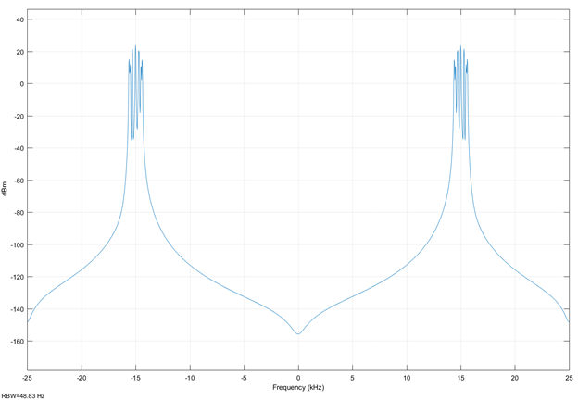

*Figure 4: Spectrum after the modulation for DSB LC.*

The transmission bandwidth of AM signal is known to be in a smaller range than FM. The upper bound for AM radio is approximately 7kHz [1]. Therefore, we can observe some contradiction here with the fact that the frequency observed on the spectrum is 15 kHz, which is higher than the upper limit.

We then observe the outputs of the signals from the spectrum point of view of the receiver (RX) and the bandpass filter (BPF). The output from the receiver can be seen in *Figure 5* and the output from the BPF can be seen in *Figure 6*.

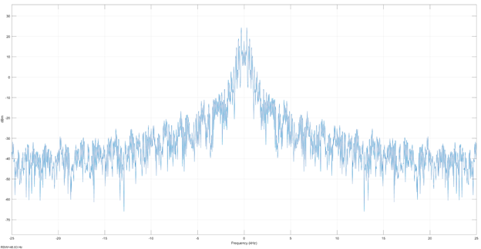

*Figure 5: Output spectrum from the receiver in DSB LC.*

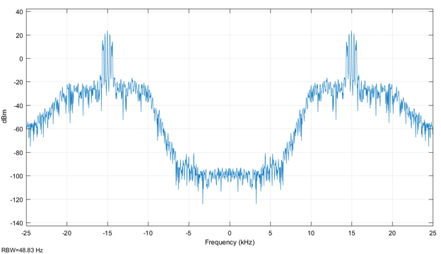

*Figure 6: Output spectrum from the bandpass filter in DSB LC.*

To filter the noise out with minimum distortion as possible, we need to know the the fundamental and harmonic frequencies. These parameters must stay the same from its initial point to after the filtering. After using a low pass filter, we can observe less noise in the output spectrum after the filtering. Therefore, the signal-to-noise ratio increases as the noise decreases. At the receiver, the noise is larger thus the SNR is smaller. Then after the filtering, the noise has been filtered, thus reduced, and the SNR is higher.

From this system, we can understand in more depth the principle of double-sideband large carrier AM demodulation. In general, modulation is defined as the process of combining an input signal and a carrier frequency to produce a signal centered at the carrier frequency. The advantage of the DSB LC is that detection can be done without a local oscillator and mixer. It can be done using an envelope detector. Demodulation is the concept of taking that envelope and extracting the signal from it, as the signal is the outer bound of the envelope.

We then change the constant for the DC bias and observe its impact on the signal. We can see from *Figure 7* and *Figure 8* the difference between a signal with a gain of 10, followed by a signal with a gain halfted.

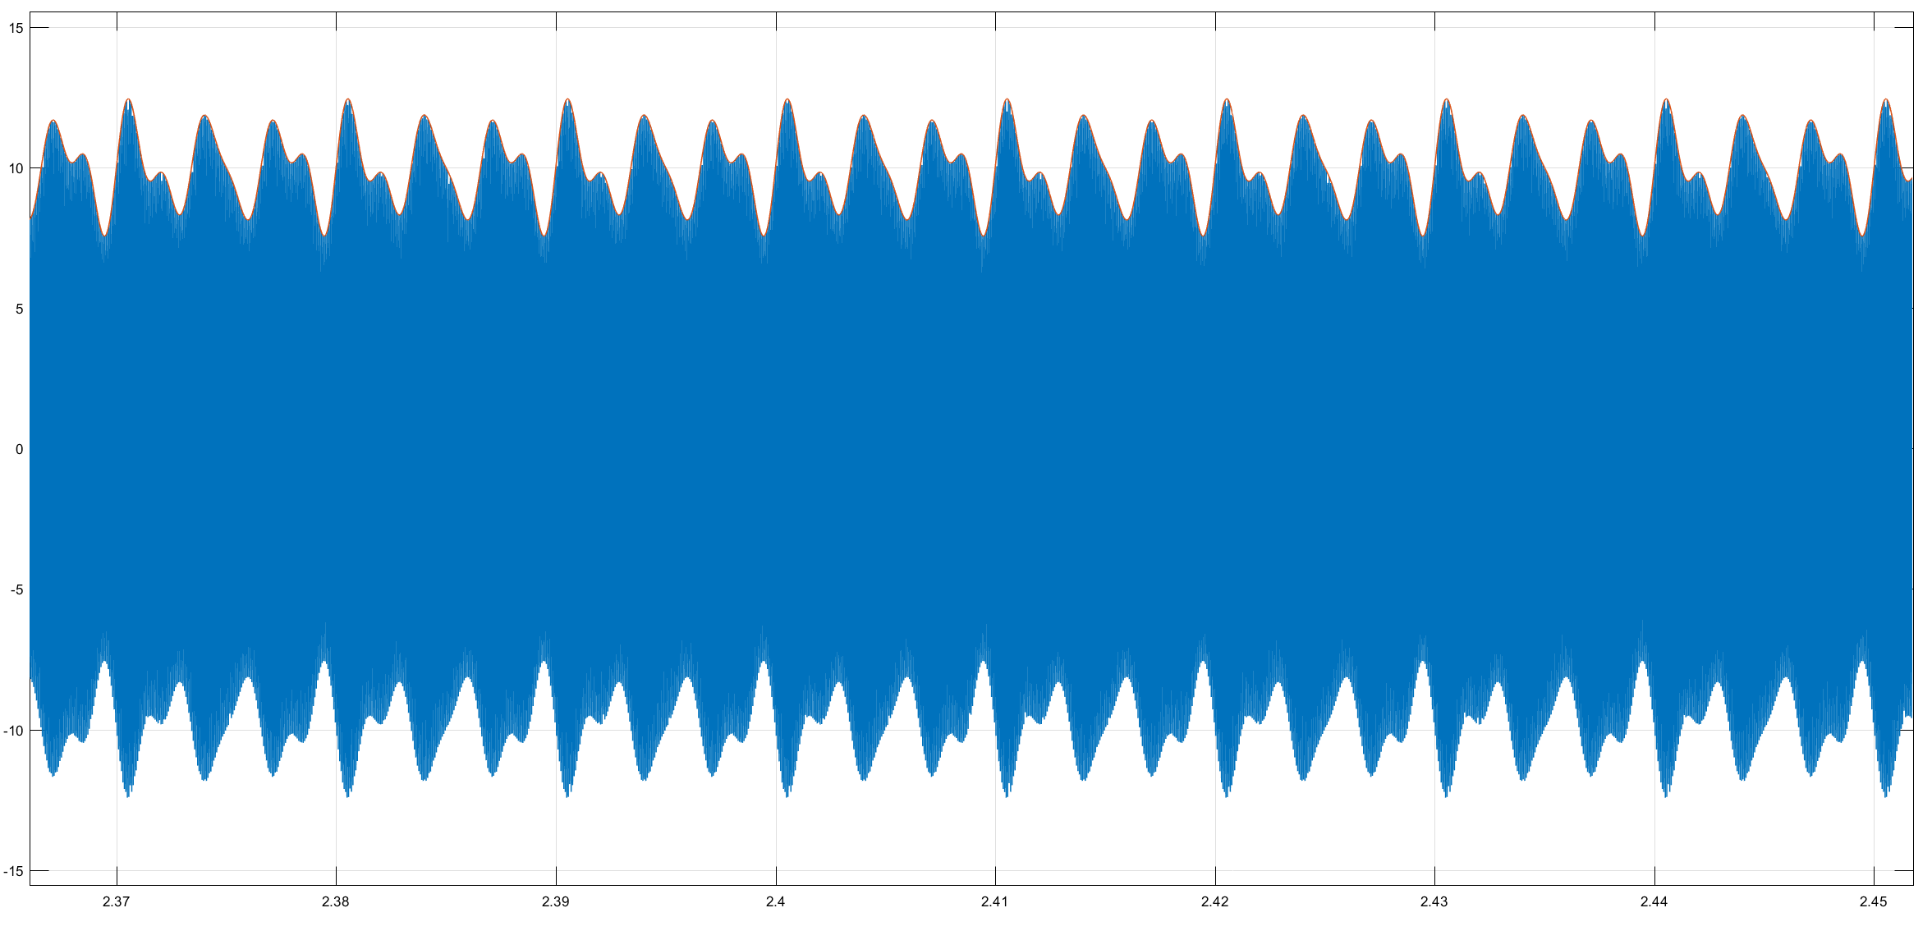

*Figure 7: Output for a gain of 10.*

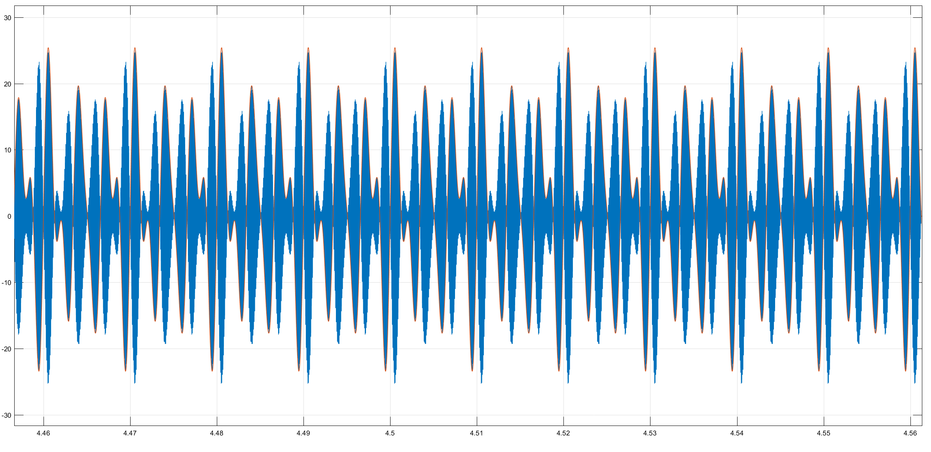

*Figure 8: Output for a gain of 5.*

Since the gain is a relationship between the output and the input, we can see how a small gain is produced from a high input SNR. Thus, we can conclude that there is no degradation in SNR of the signal for a high input SNR. When the input is smaller, the output SNR from the envelope detector is also small and reduced. *Figure 9* demonstrates the relationship between the output SNR and the input SNR.

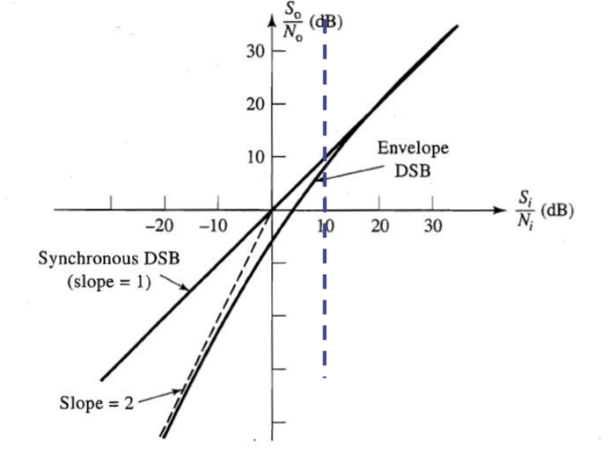

*Figure 9: Output vs Input SNR for synchronous and envelope detection of a DSB LC AM signal.*

In order to have a successful demodulation, the value of the DC bias larger than the amplitude of the input signal. Therefore, all the points will be visible and contained after demodulation.

Then, we constructed the double-sideband (DSB) suppressed-carrier (SC) AM system to see the difference between suppressed-carrier and larger-carrier. We started by observing the modulation from its scope point of view. We can see from the source signal scope and the modulator scope the relationship between the amplitude of the AM signal and the source. In *Figures 10 and 11*, the scope of the modulator and the source signal are respectively shown.

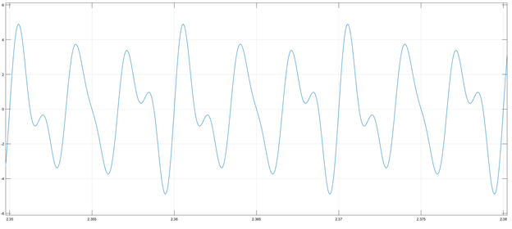

*Figure 10: Scope of source for DSB SC.*

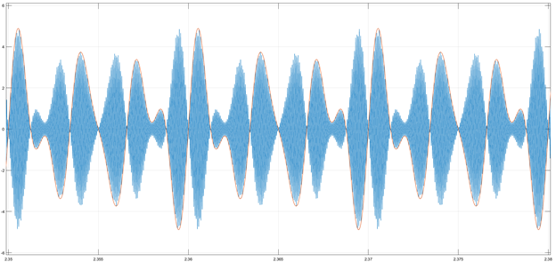

*Figure 11: Scope of the modulator for DSB SC.*

Just like with the DSB LC, the amplitude of the source signal and the modulated signal are the same. The modulated signal is simply reflected on its x-axis acting as an envelope for the source signal. The content of the envelope is a cosine wave that has been multiplied with the input source signal.

Then the relationship between the spectrum of the AM source signal and the modulated signal can be seen from their spectrum’s point of view, shown in *Figure 12 and 13* respectively.

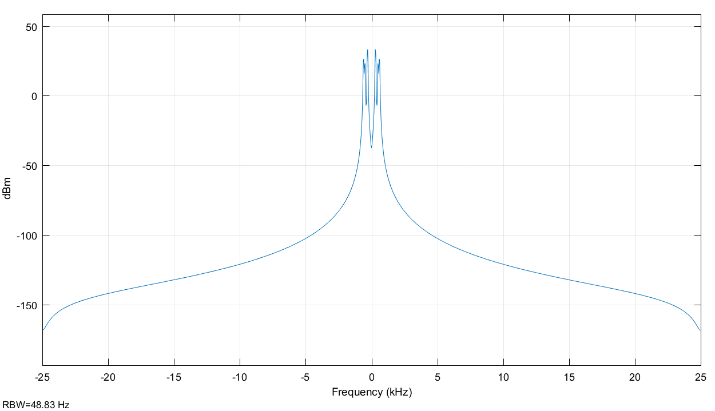

Figure 12: Output spectrum of the source for DSB SC.

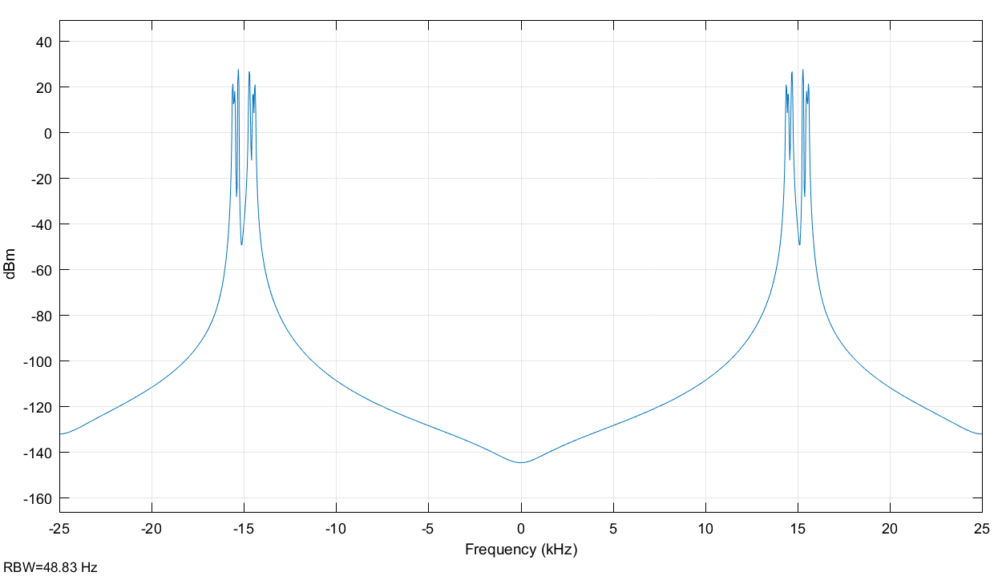

*Figure 13: Output spectrum of the modulator from DSB SC.*

The bandwidth has been duplicated in the modulated signal. This permits to have once again the frequency of the signal, which is 15 kHz.

By observing both the DSB LC and SC AM modulator, we can say how they are different. In terms of modulation, the SC perform better under low SNR values, whereas LC can be used either way. Thus, most of the power in DSB-SC is not wasted, which is more efficient; which is a tradeoff with the price of using DSB-SC over DSB-LC. DSB-SC needs oscillators at the transmitter and receiver to ensure synchronization as the carrier frequency and the phase must be identical. DSB LC needs a carrier that is larger than the amplitude of the input signal as demonstrated in the gain experiment.

Frequency Modulation

In our Frequency Modulation, we multiplied our digital sine pulse with Gain = 150, to get

150*DSP(*t*)

Then we added the Carrier Frequency = 300 Hz to it, to get

150*DSP(*t*) + 300

Then we integrated the entire sum over time [t: 0,1] and multiplied that with 2*pi.

2*ℼ*[∫01 150*DSP(t) + 300 dt]

Then we took that result and put it into the argument for cos.

s(t) = cos{ (2*ℼ*300)t + 2*ℼ*[∫010150*DSP(t) dt]}

In Frequency Demodulation we tried to extract the argument of the FM signal. We used a feedback loop multiply the signal with with itself, after being passed through a low pass buffer filter with cut-off frequency = 2*pi*10 and VCO to remain in phase with the carrier of the incoming signal. What this does is, removes the FM signal, because it is a high frequency component and we get the DSP in the output of the VCO. We extracted the real part of the received signal and sent it back to the matrix multiplier and also as our Scope (Demod). This entire process is called Phase Locked Loop FM Demodulation.

Then we observed the Scope (Mod), Figure 14, for a cosine wave a carrier frequency. The FM signal s(t) is a cosine trigonometric function, which is due to the modulating signal being cosine.

Figure 14: Scope (Mod) 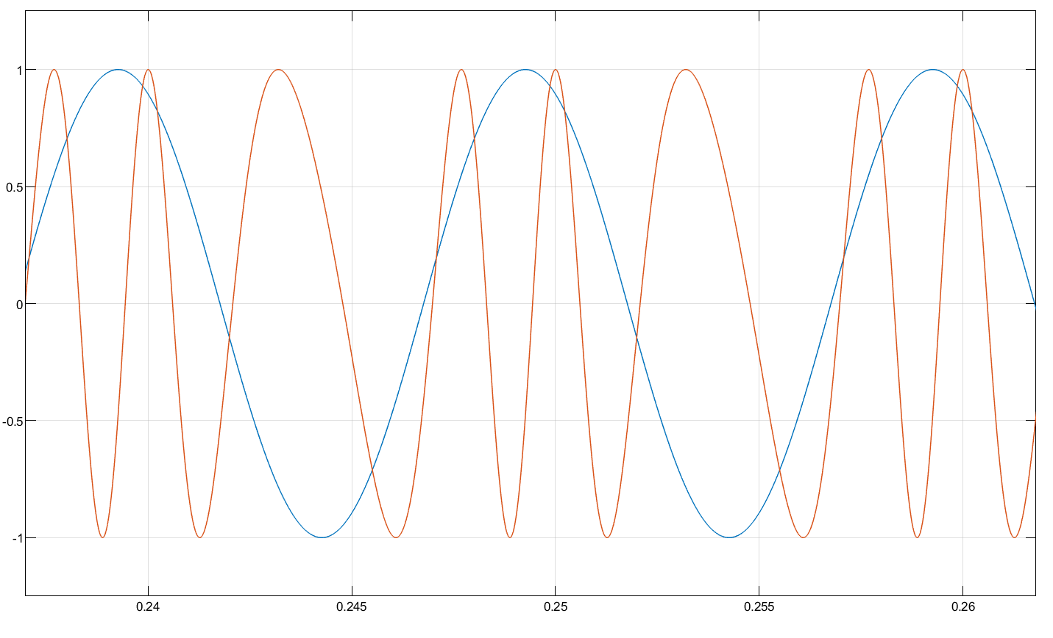

We then used the sum of two cosine waves aa modulating signal, we get the following 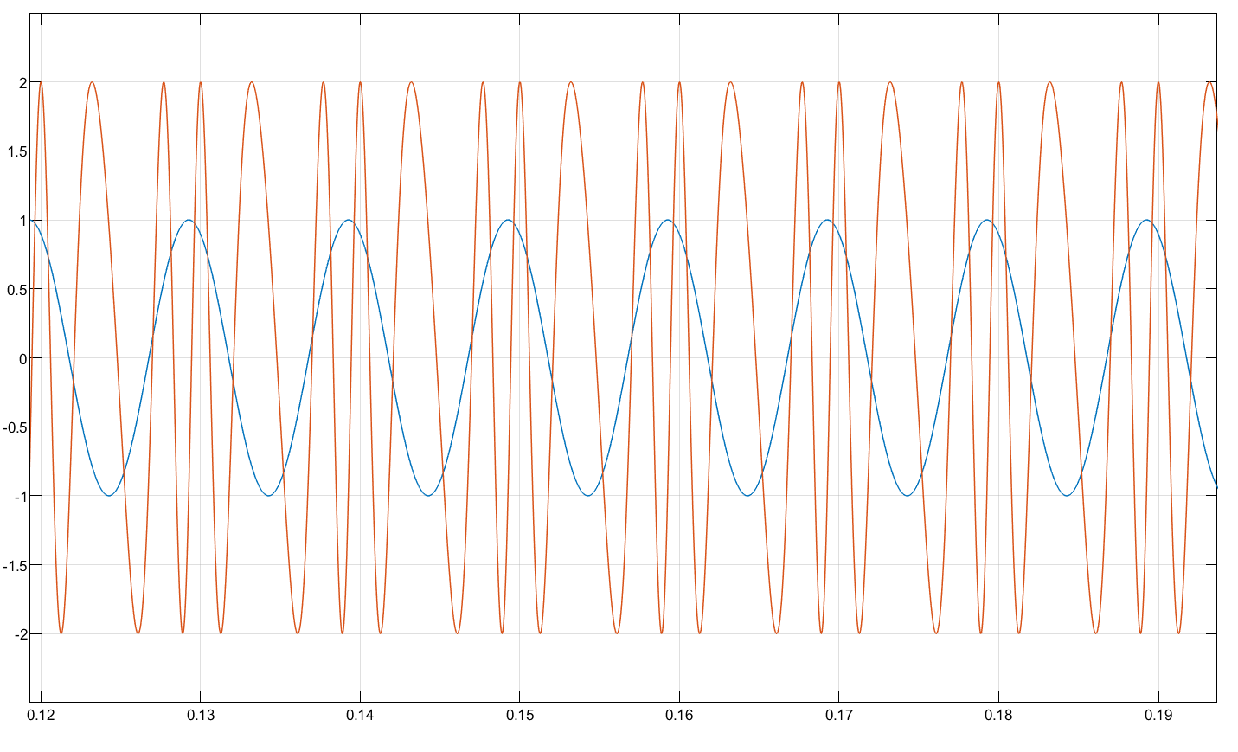

Figure 15: Scope (Mod), sum of cosine

When we use the sum of sine wave, our FM signal amplitude is the sum of all the individual modulating signals. Here we see the Scope (Mod) in Figure 15 has a wave with twice the amplitude, due to having two cosine waves instead of one cosine wave, Figure 14. This shows FM modulation being a linear process.

For a Modulation Index, 𝜷 < 1 we get the FM signal shown in Scope (Mod) in Figure 14. For a 𝜷 > 1, we get FM signal in Figure 16.

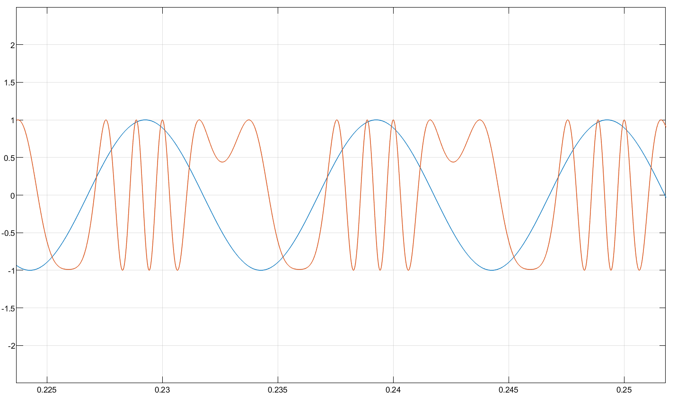

Figure 16: Scope (Mod), 𝜷 > 1

As 𝜷 changes, the frequency of the FM signal is not affected, because that is dependent on the carrier frequency, and not Gain sensitivity factor. The amplitude is not affected as well, because changing 𝜷 only affects the argument of the modulating signal and not its amplitude. We can observe all this in Figure 16.

The more frequency we give for carrier, the more it will envelope the signal we are sending as long as 𝜷 < 1. For 𝜷 > 1, the carrier does not envelope the signal properly. In conclusion, the amplitude remains the same, but the frequency increases until we reach 𝜷 = 1.

With a lower carrier frequency, 300 Hz, we the following Spectrum (Mod), Figure: 17. We observed Channel Power = 26.887 dB

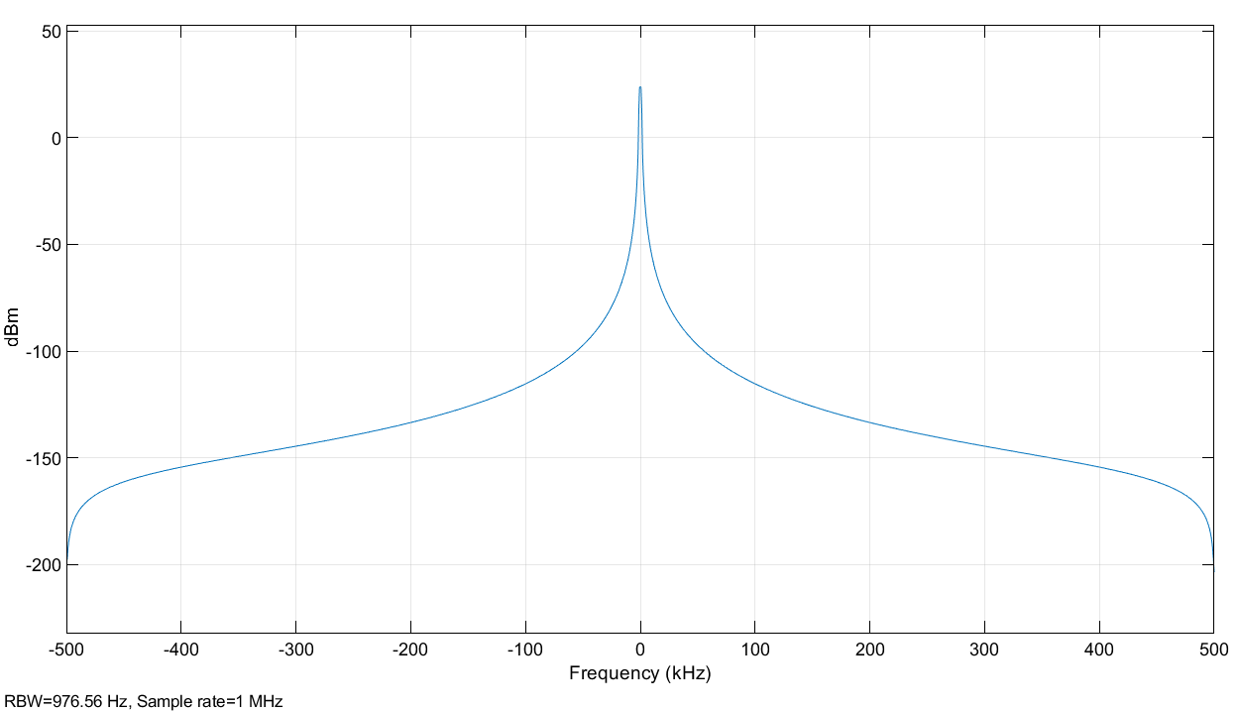

Figure 17: Spectrum (Mod)

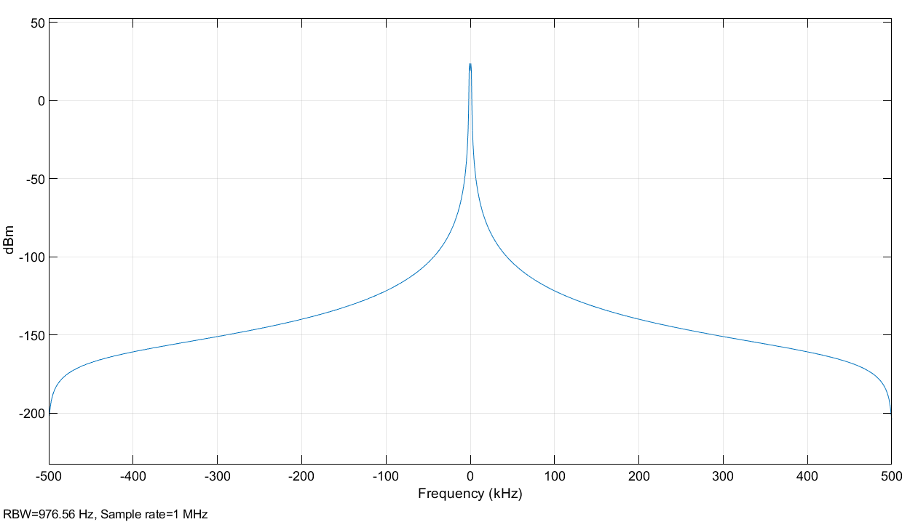Figure 18: Spectrum (Mod)

With a higher carrier frequency, 600 Hz, we get the Spectrum (Mod), Figure 18, with Channel Power = 27.008 dB. We can observer from both the Spectrums, the Channel Power has negligible change due to change in carrier frequency.

We can increase the amplitude of the carrier signal, to perform AM. In Figure 19, we increased the amplitude to 5. We observe Channel Power = 40.857 dB.

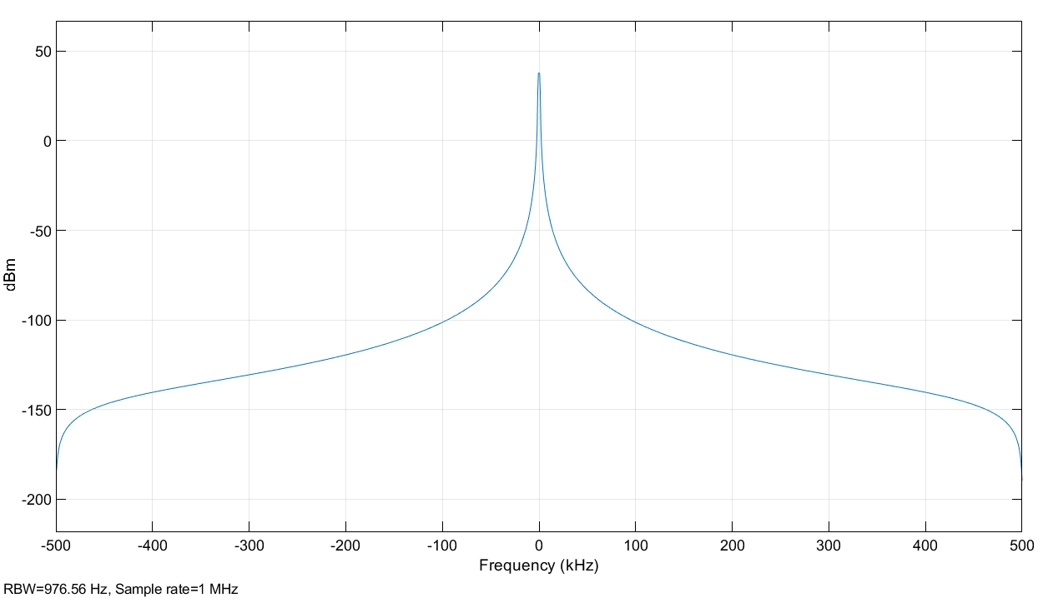

Figure 19: Spectrum (Mod)

The transmit power changes in AM signal rather than in FM signal. Because in FM, we are trying to change the frequency of the transmitted signal, and not affect its amplitude at all. Channel power thus remain unaffected. In AM, we add a gain to the transmitted signal, causing the channel power to increase.

Power/Bandwidth trade-off in FM

This part of the lab was done with fm = 3000 Hz. We varied the frequency of the Gain (Δf) to get different spectrums and realize the differences in terms of SNR and CBR values. We also observed the CBR Power transmitted and the pre-detection SNR and post-detection SNR.

First we observed the spectrum for different Gain values, Δf (Hz): [300, 1500, 3000, 15000, 30000].

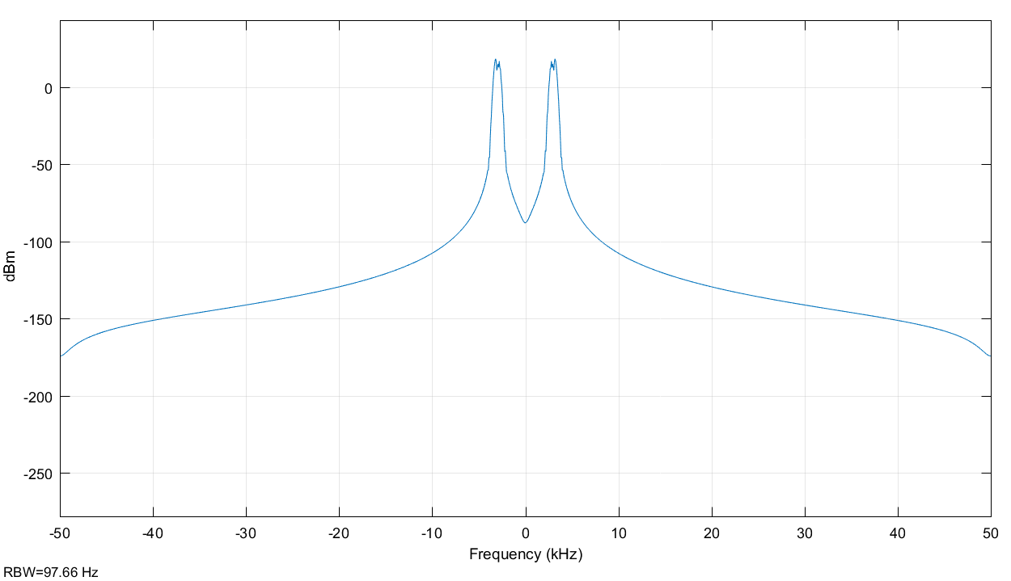

Figure 20: Gain = 0.1fm

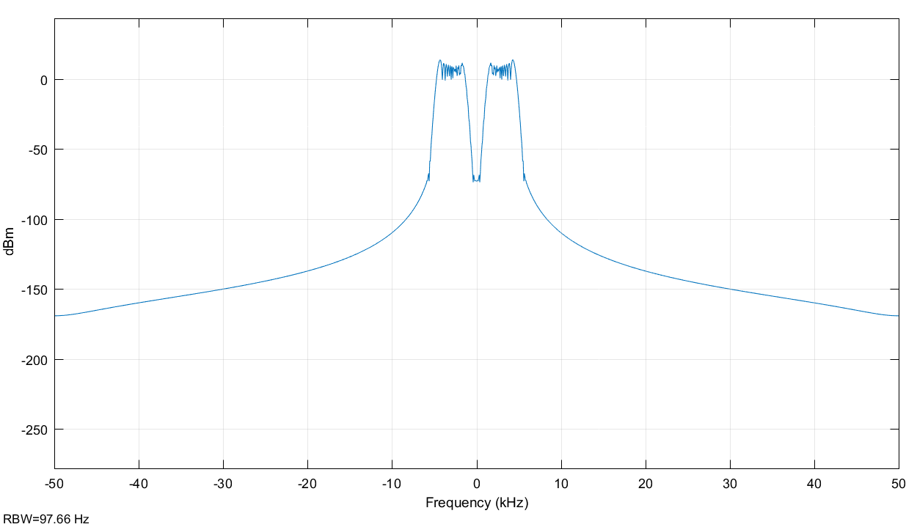

Figure 21: Gain = 0.5fm

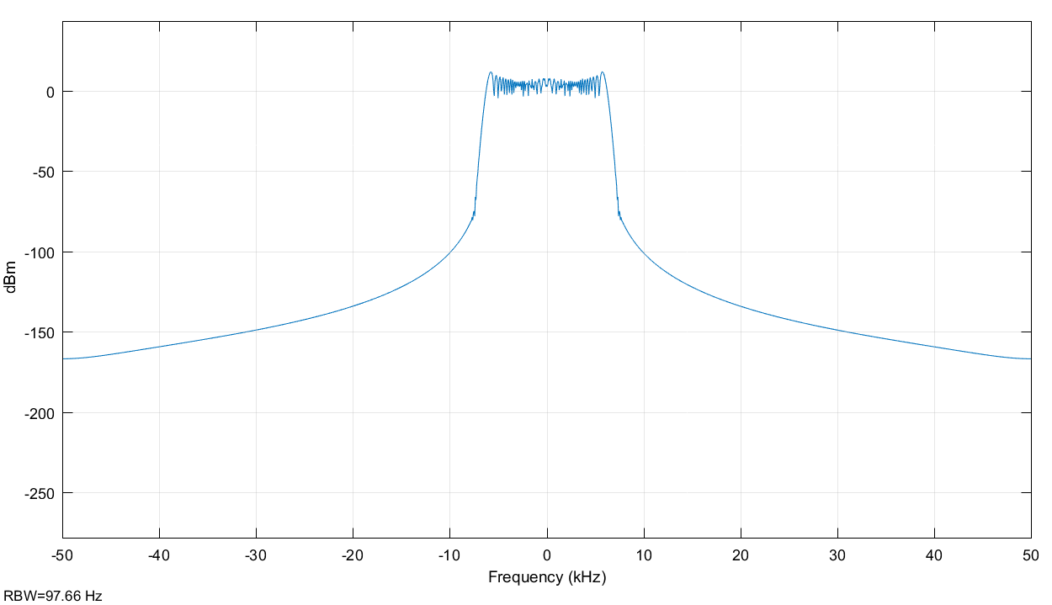

Figure 22: Gain = fm

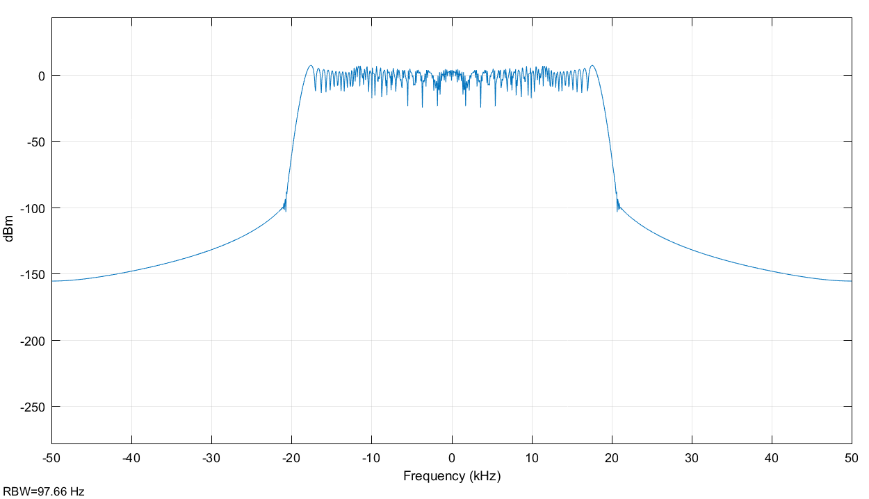

Figure 23: Gain = 5fm

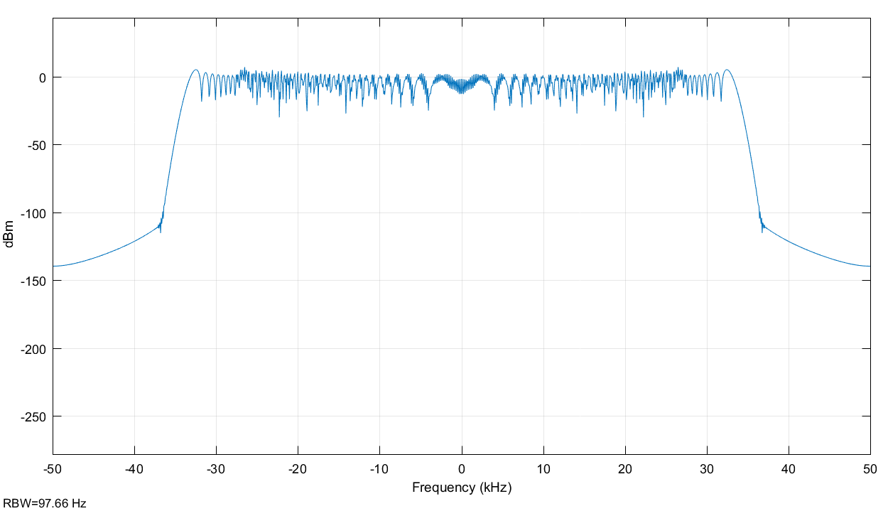

Figure 24: Gain = 10fm

The following table displays the values for power, CBR and CBR Power transmitted for different values of Δf.

|  |  |  |  |
| --- | --- | --- | --- |
| Δf (Hz) | Power (dB) | CBR (Hz) | CBR Power (dB) |
| 300 | 26.99 | 6600 | 26.599 |
| 1500 | 26.99 | 9000 | 26.776 |
| 3000 | 26.739 | 12000 | 26.563 |
| 15000 | 23.546 | 36000 | 26.925 |
| 30000 | 20.388 | 66000 | 26.951 |

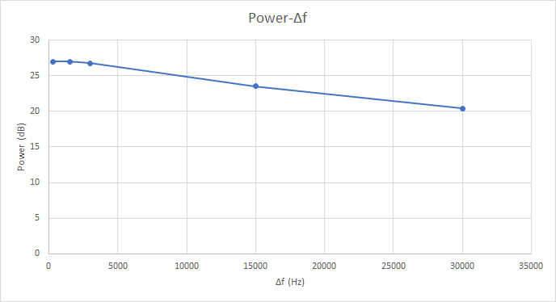

Figure 25: Power-Δf

Pre-detection SNR vs Post-detection SNR

|  |  |  |
| --- | --- | --- |
| Δfm (Hz) | Pre-detection SNR (dB) | Post-detection SNR (dB) |
| 300 | 16.99 | 82.99 |
| 1500 | 16.99 | 82.83 |
| 3000 | 16.72 | 83.02 |
| 15000 | 17.08 | 82.77 |
| 30000 | 17.05 | 82.84 |

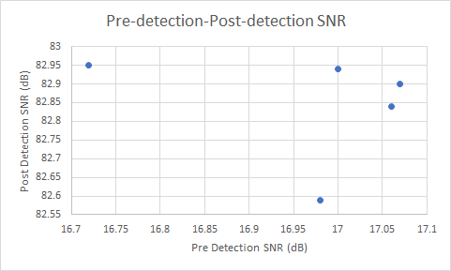

Figure 26: Pre-detection vs Post detection SNR

As Δf increases, SNR values increase overall.

In conclusion, Part 1 and 2 went well. Part 3 did not go as expected, maybe taking different Carriers and more variations of Δf could help make results clearer.

REFERENCES

[1] W. Stallings, “Data and Computer Communications,” Pearson Education, Inc. 10th ed. 2014. [pdf], [Accessed Oct. 12, 2018].